PAGE 1 :

Logo
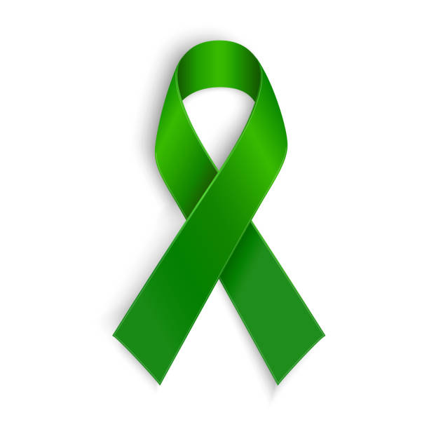

Website Name :

THE AWARENESS SPACE

Colour of Website: White

Button 3 (3 garis melintang as menu tu) :

- Mental Health News ( dashboard)
- Feedback

Picture :
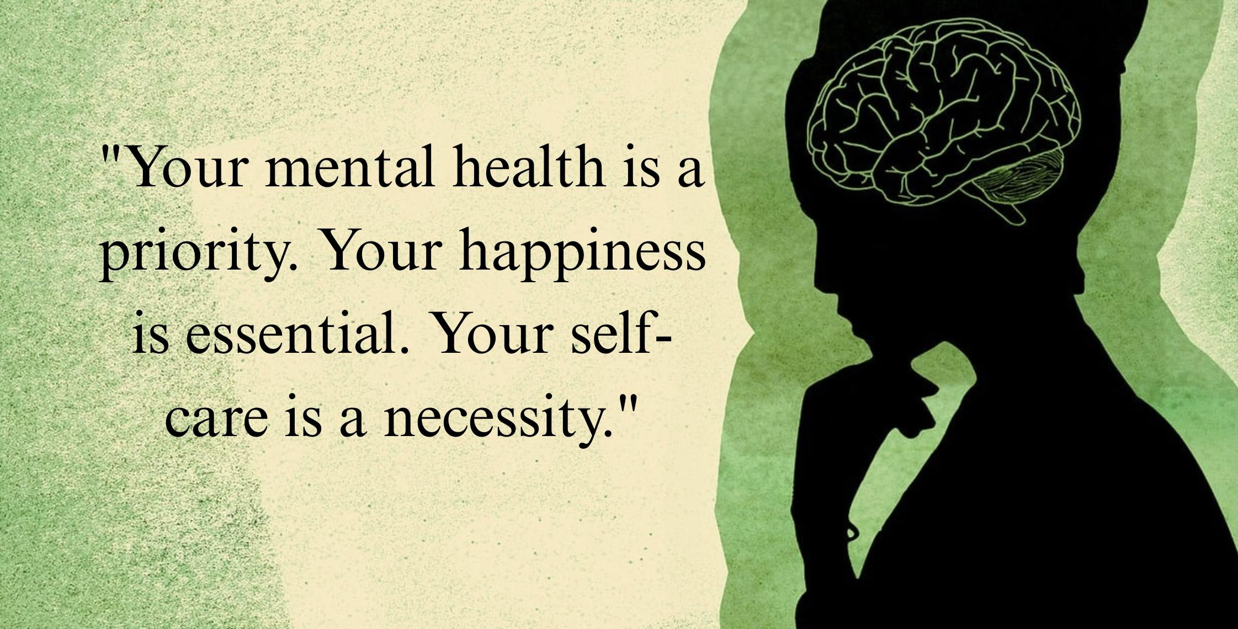

Mini Dashboard :
*Static Display
Example design & background for mini total cases data;
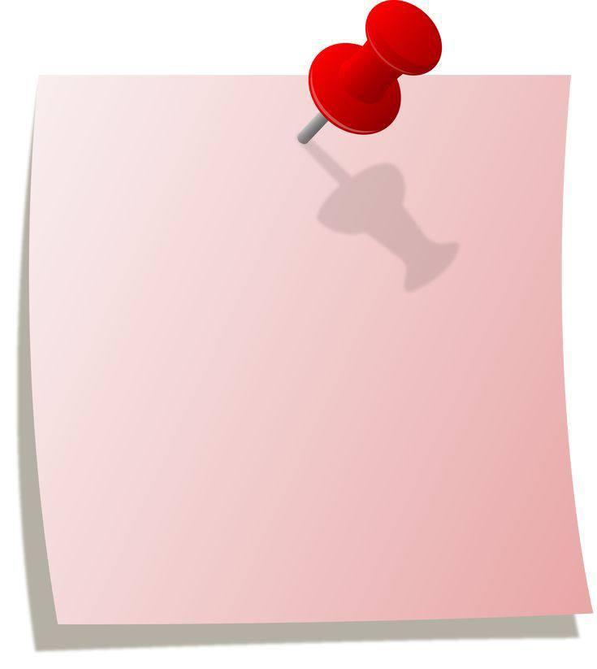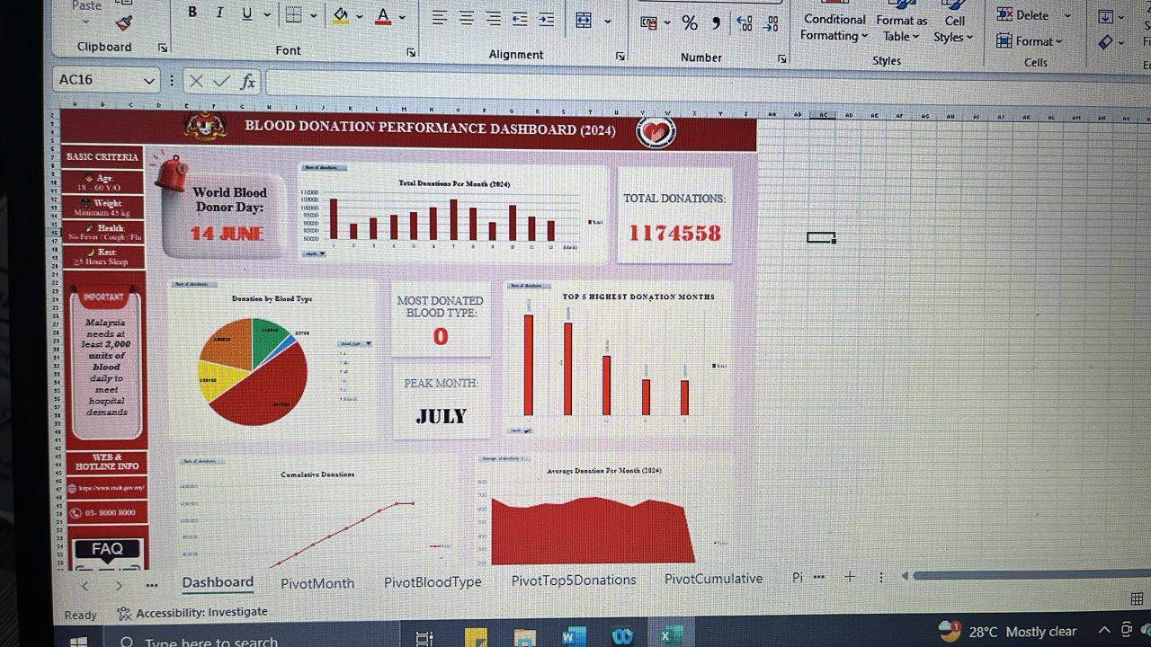

Total Mental Health for Today: 4.6% (> 1 million cases)
Total Suicide Cases Until Today: 4,440 cases
📞 Talian HEAL (Help with Empathy And Love): 15555

Article:
https://www.who.int/westernpacific/newsroom/feature-stories/item/strengthening-minds---malaysia-strengthens-efforts-to-enhance-the-mental-health-of-children-and-adolescents
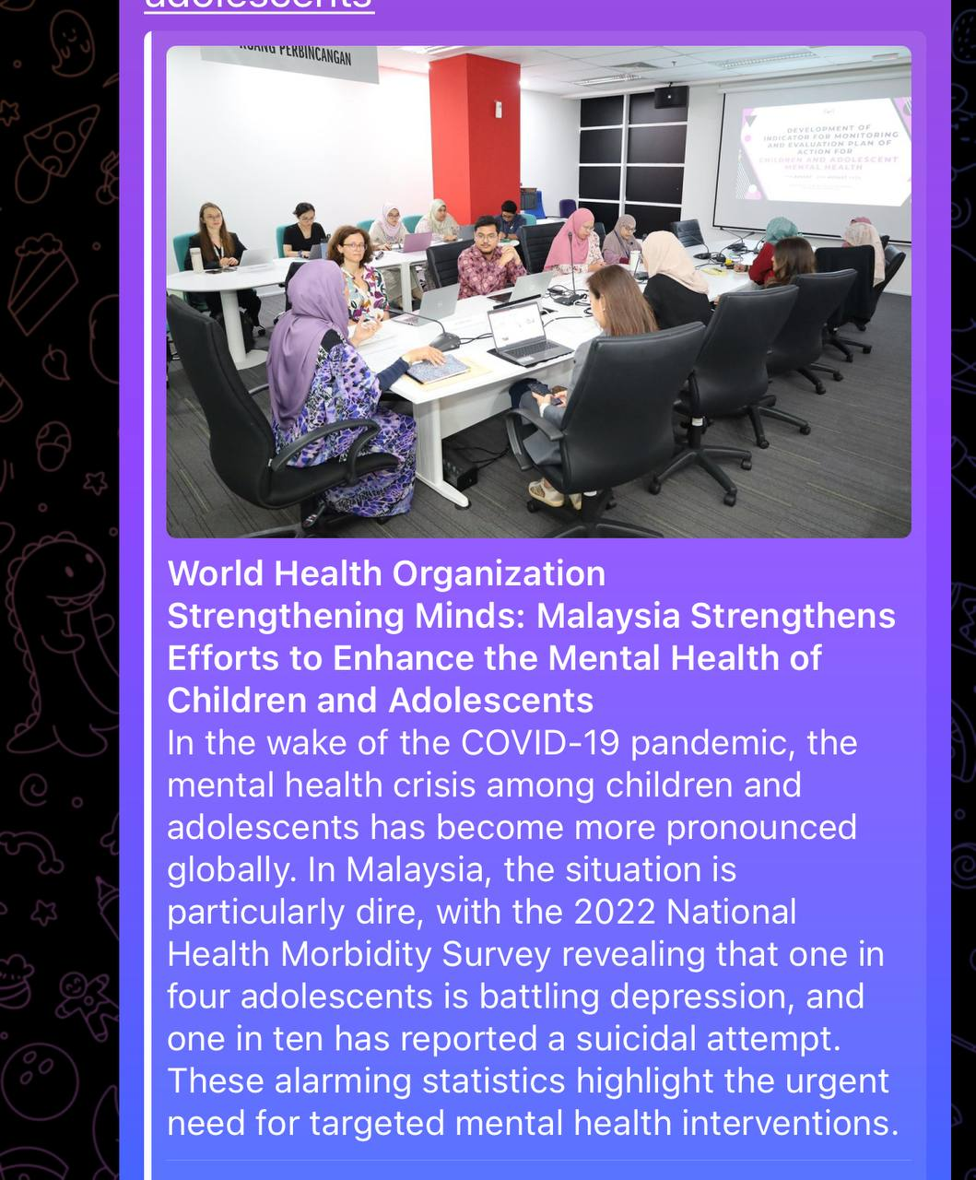

P/S : nnti bahagian display article dlm website ikut je ayat dan gambr atas ni

Contact Info:

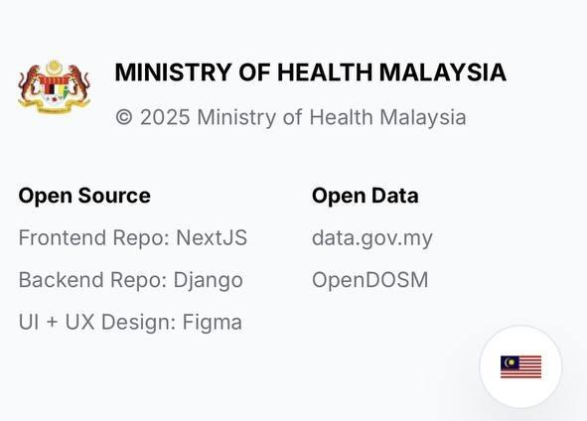

PAGE 2 :

Data
Untuk Line Chart : Total Mental Health Cases Reported from 2020 to 2025

📊 General Mental Health Cases in Malaysia (2020–2025)
Year | Estimated Prevalence / Mental Health Related Activity (%)
2020 | ~85%
2021 | ~83%
2022 | ~70%
2023 | ~65%
2024 | ~60% (estimated, recovery phase ongoing)
2025 | ~60% (estimated, stable post-pandemic levels)

Pie Chart:
Note : est = estimate

- Anxiety:

📊

Anxiety Prevalence in Malaysia by Gender (2020–2025)
Year | Females (%) | Males (%) | Notes
2020 | 6.3% | 7.3% | Among hospitalized COVID-19 patients (Apr–Jun)
2021 | ~49% | ~41% | General population (SE Asia avg., DASS-21 survey)
2022 | 54% | 38% | Self-reported increased anxiety (Rakuten Insight)
2023 | ~6.0% | ~4.0% | Estimated based on post-pandemic recovery
2024 | ~5.8% (est.) | ~3.8% (est.) | Projected, based on trend
2025 | ~5.5% (est.) | ~3.6% (est.) | Projected, based on trend

- Depression:

📊 Depression Prevalence in Malaysia by Gender (2020–2025)
Year | Females (%) | Males (%)
2020 | 4.8% | 3.4%
2021 | 5.0% | 3.6%
2022 | 5.2% | 3.8%
2023 | 5.4% (NHMS) | 3.9% (NHMS)
2024 | 5.5% (est.) | 4.0% (est.)
2025 | 5.6% (est.) | 4.1% (est.)

- Self Harm & Suicide Suicide Attempts:

📊 Suicide and Self-Harm Cases by Gender (% of Total Cases) — Malaysia (2020–2025)
Year | Male Suicide (%) | Female Suicide (%) | Male Self-Harm (%) | Female Self-Harm (%)
2020 | 73% | 27% | 38% | 62%
2021 | 72% | 28% | 38% | 62%
2022 | 73% | 27% | 38% | 62%
2023 | 73% | 27% | 38% | 62%
2024 | 73% (est.) | 27% (est.) | 38% (est.) | 62% (est.)
2025 | 73% (est.) | 27% (est.) | 38% (est.) | 62% (est.)

Bar Graph:
Example: (2020: Gen Z, millennials, Gen X, Gen alpha) , ( 2021: Gen z, millennials, Gen X, Gen alpha)

📊 Estimated Yearly Mental Health Prevalence by Generation — Malaysia (2020–2025)
Year | Gen Z(1997–2012) | Millennials(1981–1996) | Gen X(1965–1980) | Gen Alpha(2013–2025)
2020 | 28% | 24% | 18% | 10% (early signs in older Alpha)
2021 | 32% | 27% | 20% | 12%
2022 | 30% | 26% | 19% | 13%
2023 | 31% | 27% | 20% | 14%
2024 (est.) | 32% | 28% | 21% | 15%
2025 (est.) | 33% | 29% | 22% | 16%

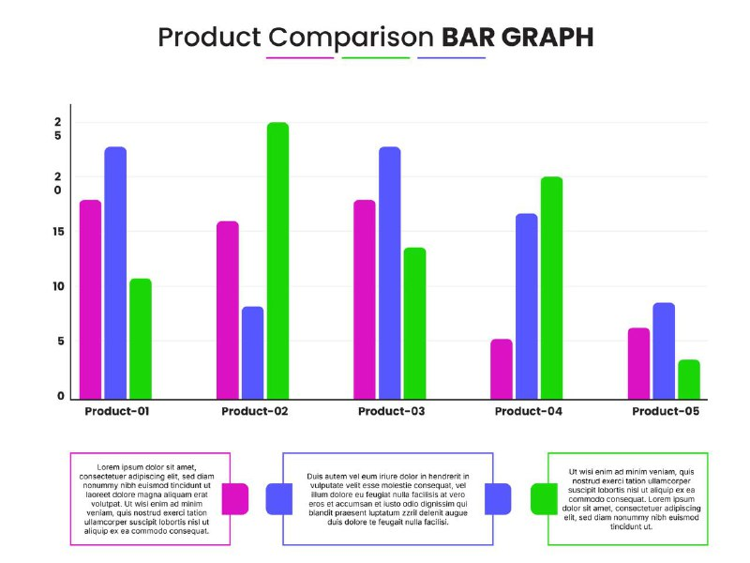

PAGE 3 :
Feedback (kindly refer pdf for design)

